First Draft – Classification Model COVID 19

Nachi Lieder

April 19th 2020

**Preliminary Assumptions**

1. Our target variable is PCR , Meaning the objective is to predict whether the PCR was positive or negative.
2. The model needs to be released as quick as possible , which points to an easy implementation and integration if needed
3. Intuitive model , no use of Deep Learning methods , to simplify the model and make it easier to understand and utilize.
4. Adaptive model , the model will be adaptive to new data , and will re-train itself every period that we define to improve performance.
5. There is no meaning to the order of the patients in the dataset.

**DATA EXPLORATION**

There are 294 patients in the set , 38% of them are labeled with a positive PCR.

The model is based on 8 binary variables plus 2 categorical variables.

The variables and their distribution:

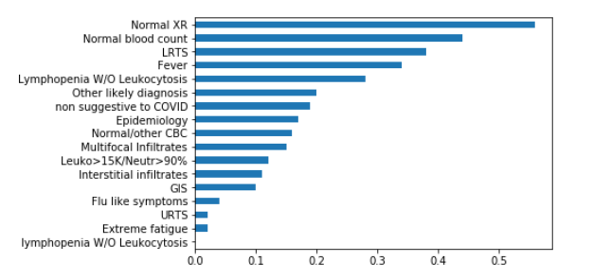

To create a more sophisticated model , and capture as much variance as possible , I decided to treat the categorical variables as categories and not pool them as a binary variable.

I created encoding - dummy variables to binarize each category within the variable.

HEATMAP Correlation Matrix

I decided to view the inner correlations between variables per patient . Example – Normal XR and Normal Blood Count have a positive correlation. This makes sense.

Also , there is a negative correlation between Multi Infiltrates and Normal XR. This too makes sense.

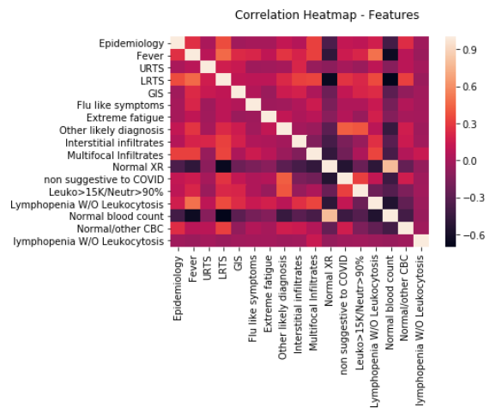

I decided to create a mutual effect of “And” between the binary variables to capture the inner correlation and variance. Example – We would have a feature called Epidemiology , and another feature called Fever. There will now be a new feature called Epidemiology_Fever which will indicate whether the patient had both symptoms.

**Method of test**

I split the sample into 2 sets. The first set is the training set , which pertains 70% of the samples. The second set is the Test Out Of Sample set (OOS) , which pertains the remaining 30%.

The training set is built to train the model , while the OOS is to test the performance of the test on a set that hasn’t been seen by the model before. This keeps away from overfitting.

In later stages , I performed a cross-validation of the entire set , splitting the entire set into 5 random sets , training the model on every 4 , and testing on the 5th. This was to ensure I wasn’t overfitting or wasn’t biased towards a certain subset of the larger dataset.

**Metrics**

I didn’t settle on one metric since each metric has its pros and cons, and needs to be taken under consideration while evaluating the models performance.

* **AUC and ROC curve** – Scoring method which measures different thresholds and presents the different outcomes per threshold.
* **Precision Score** – The ability to measure how many positive results relative to all the results I was correct with. Sensitivity
* **Recall Score** - The ability to measure how many positive observation I was correct with , from all the positive predictions my model projects.
* **F1 Score** – joined metric taking into account precision and recall
* **Accuracy** – Percentage of correct labeled observations from set of predictions
* **Confusion Matrix** – Distribution of predictions in a formatted matrix.

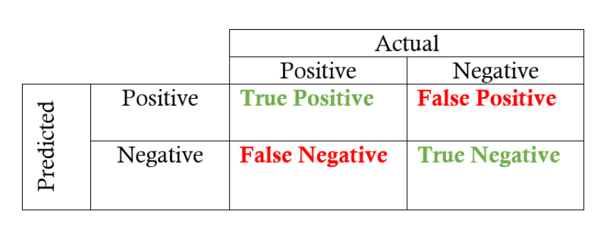

***The Models***

I decided to go forward with 2 models, and test them both against the current existing classifier.

**RANDOM FOREST**

This model is a decision tree based model. The machine creates multiple trees and creates a voting system . All the trees individually classify a given observation , and through a vote , the decision is made. The fact that it is a “forest” and not a single tree makes the model much more robust for a minor error. This model is used commonly.

**Logistic Regression**

The logistic regression is fast , easy and has proven its effectiveness in the ML industry.

Using the given features , the model tries to create a sigmoid function that will optimize the differentiation between classifying 0 and 1.

The default is that the model will classify f(x)>0.5 -🡪 True , else False. Though we can manipulate the thresholds and decide according to the strictness of each type of error , what our thresholds will be and work with those going forward.

Score to PCR matching – Current Classifier

I decided to use the current classifier as my benchmark.

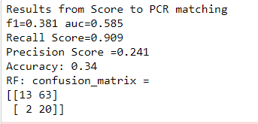

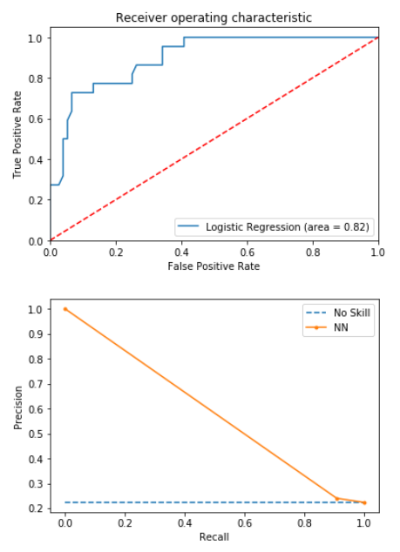

Against this , I compared my two different models , with hope that one will satisfy all the different criteria of the client.

**Model 1 - RANDOM FOREST:**

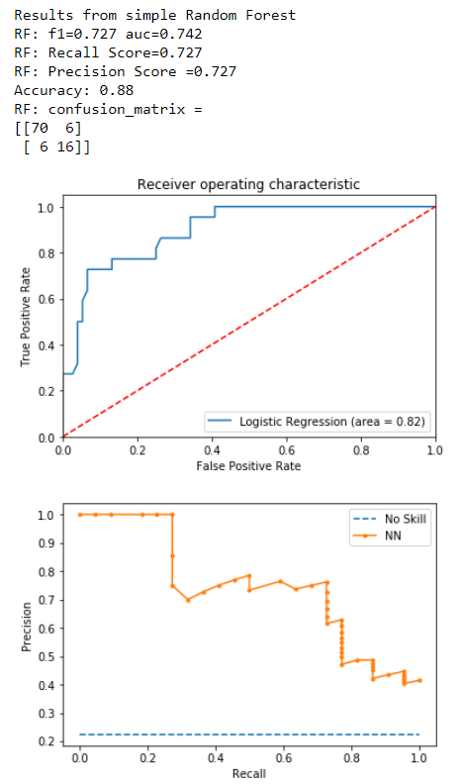

**Model 2 – Logistic Regression**

